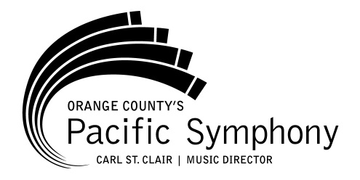
MEDIA CONTACT:
Jean Oelrich
Director of Marketing and
Communications
(714) 876-2380
joelrich@pacificsymphony.org

Media Advisory

pACIFIC SYMpHONy Musicians TO perform eclectic program
“artists unite” June 29 AT ORANGE COUNTY CENTER FOR CONTEMPORARY ART IN DOWNTOWN SANTA ANA

“Artists Unite” presents Pacific Symphony Musicians with
Guest Artists, pianist Gloria Cheng and vocalist Carver Cossey

Who: Pacific Symphony musicians at Orange County Center for Contemporary Art (OCCCA), with guest artists, pianist Gloria Cheng and vocalist Carver Cossey.

What: The “Artists Unite” program is a unique and eclectic experience for music and art lovers at OCCCA, an alternative art space in Downtown Santa Ana. Curated for the musically and culturally curious, “Artists Unite” features a diverse mix of musical compositions from Crumb to Rzewski, and Glass to Daugherty, performed by Pacific Symphony musicians and guest artists, pianist Gloria Cheng and vocalist Carver Cossey. The event focuses on the unique artistic perspective that composers have used to highlight meaningful issues of their time, including environmentalism, peaceful protest and socio-political justice. Join us for pre-concert entertainment, featuring live music, craft beer and wine at 7:15 pm. View OCCCA’s current exhibition, “Art as Protest.”

When: Thursday, June 29, at 8 p.m. Tickets are $20 and available at www.PacificSymphony.org or (714) 755-5799.

Where: Orange County Center for Contemporary Art, located at 117 N Sycamore St, Santa Ana, CA 92701.

Why: “Artists Unite” is a culturally relevant way to experience a wider range of classical styles of music than is typically found in traditional concerts.

